A shortish autobiography of Jeff Rushen (written by himself)

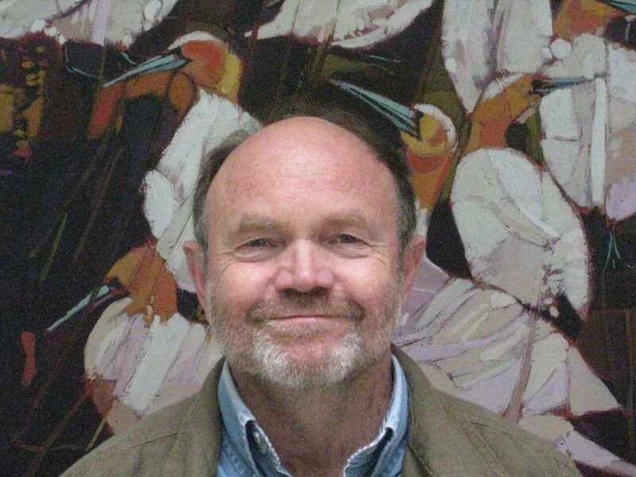
I have had a fantastic life as a scientist finding out interesting things about many aspects of animal behaviour and welfare, and would strongly recommend this as a career choice to anyone considering it. My research has ranged from studying the peck order in poultry, through developing stress measures in sheep and cattle, and studying aggressive, stereotypic and nursing behaviour of pigs, to developing methods for welfare assessment of zoo elephants. My recent research has focussed on the behaviour and welfare of dairy cattle, especially human-animal relationships, automated detection of lameness, robotic milking of cows, group housing for calves, and on-farm welfare assessment protocols. My most recent interest is in positive welfare states and play behaviour of calves, and in exploiting farm animals’ cognitive abilities to both improve the efficiency of animal production as well as improve the welfare of the animals.
Among my most interesting findings (at least, for me) is that the sequence of postures adopted by pigs while fighting reflects their attempts to bite while avoiding being bitten, that stereotypic behaviour of pigs is more related to feeding problems than to restricted housing, that adult cows can recognize people by their faces, and that locomotor play in calves is related to exploratory behaviour.
In a long partnership with my beloved friend and collaborator (Anne Marie), I have mentored many post-doctoral fellows, post-graduate and under-graduate students from around the world, have published many scientific articles on farm animal behaviour and welfare and have contributed to several books and book chapters. I firmly believe that to convince the tax payer to continue funding research, it is important to apply research findings to areas of public interest. Consequently, I have accepted to be a member of several national or international committees reviewing or developing welfare standards for farm animals (e.g. European Food Safety Authority, The National Farm Animal Care Council of Canada), hoping that this does something to improve the lot of farm animals.
I really like the International Society for Applied Ethology, and have attended its conference as often as I could. I was very touched and honoured at being selected to be an Honorary Fellow in 2014. I served for over a decade as council member and editor, and during this period the society both had a name change and started having annual conferences outside Europe / North America (and I am proud of my contribution to achieving these). I gave the David Wood-Gush lecture at the ISAE congress in Brazil in 2000.
I completed my B Sc in psychology and zoology and a PhD in animal behaviour at the University of Queensland in Australia, way back in the 70’s and 80’s. I was an Alexander von Humboldt fellow at the Institute for Animal Husbandry and Animal Behaviour in Trenthorst, Germany and was awarded a post-doctoral fellowship from the Natural Sciences and Engineering Council of Canada at Agriculture Canada in Ottawa.
I am currently an adjunct professor at the University of British Columbia in Vancouver, Canada, and previously held research positions at Agriculture and Agri-Food Canada (in Quebec and British Columbia), the University of Alberta, the University of Melbourne, and the University of Queensland. I have enjoyed frequent and lengthy (but too few and too brief) collaborations at the University of Aarhus, the University of Hiroshima, the University of Helsinki, INRA Clermont-Ferrand, the University of Melbourne, Wageningen University, and the Swedish University of Agricultural Sciences in Skara (where I was improbably employed briefly as a chauffer). A definite benefit from my career choice is having met such nice and interesting people from so many different countries.

