Autobiography
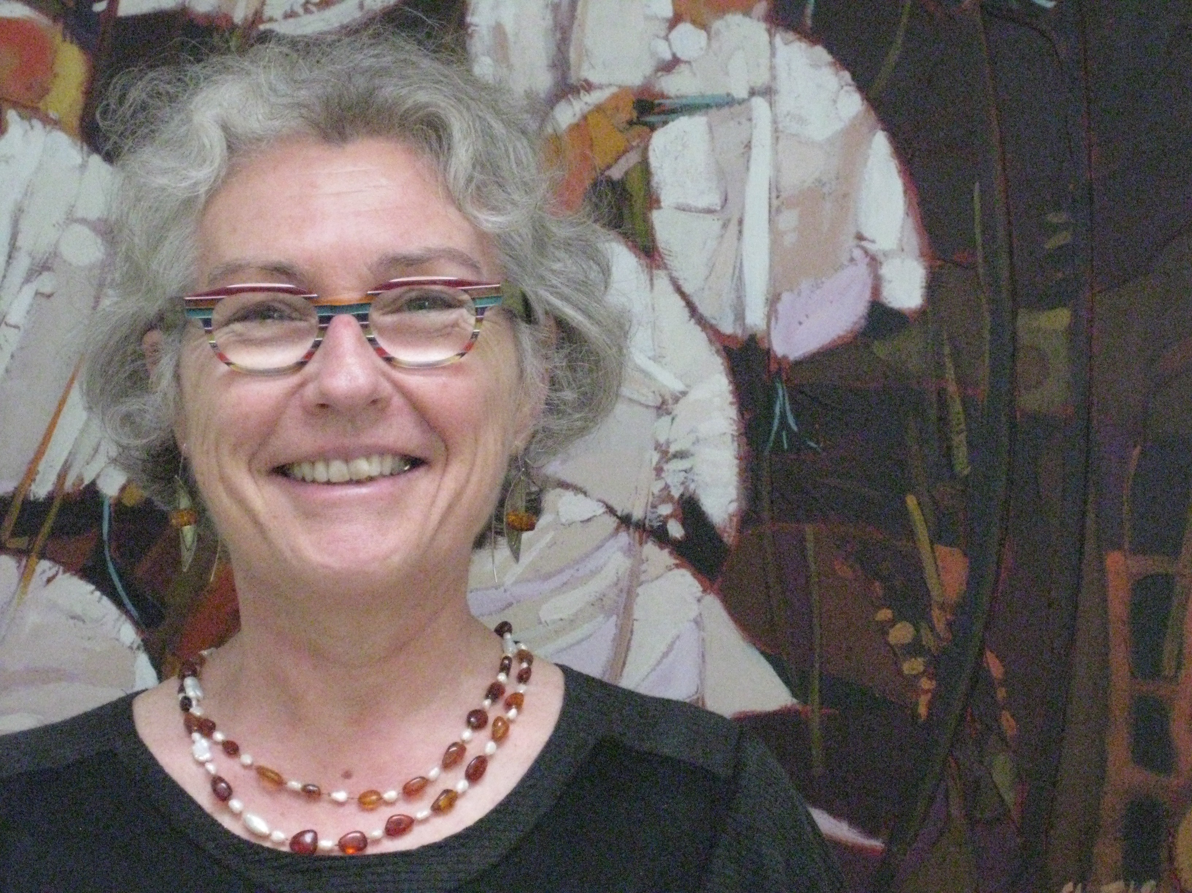
I have greatly enjoyed my career as a scientist studying animal behaviour and welfare, and have very much appreciated being involved with the International Society for Applied Ethology where I have made many friends and found many wonderful collaborators. I feel honoured being selected as an Honorary Fellow.
I started my research career studying piglet suckling behaviour and examining piglet –dam interactions, sow hormonal changes during farrowing and nursing as well as piglet development and growth as affected by competition between litter mates. Since then, my research has focused on the behaviour and welfare of domestic animals, most recently of dairy cows and calves, and I have carried out and collaborated on research on pigs, beef cattle and zoo elephants. I have collaborated with research groups on four continents. My research has elucidated the motivation of sucking behaviour. For example, I showed that he performance of sucking behaviour helps stimulate the secretions of hormones involved in metabolism. My research also helped find methods of controlling abnormal sucking behaviour of dairy calves and has demonstrated improved methods of feeding and group housing calves and for weaning them off milk to help protect their welfare. I have continued investigating cow-calf interactions with studies on cow hormonal changes during milking and suckling. I have also collaborated in studies examining nursing behaviour and cow-calf rearing.
I have developed improved methods of detecting lameness in dairy cows and also shown the extent that farm animals’ fear of people can impact their welfare and productivity. Most recently, I was the leading scientist of a national research project that helped develop an on-farm welfare assessment protocol for dairy cows, that is being used by the Dairy Farmers of Canada. In the last few years I have collaborated in studies of calf learning examining how to train calves to urinate and defecate in one place.
I am an adjunct professor at the Universities of British Columbia, Saskatchewan and Laval, and a Special Graduate Faculty Member at the University of Guelph, and was a Senior Research Scientist for Agriculture and Agri-Food Canada from 1979 until 2014.
I received my B. Sc. degree in Biochemistry, and M. Sc. in Nutrition , and Ph. D. in Behaviour from McGill University in Canada. I did postdoctoral research at the Wageningen Agricultural University in the Netherlands. I have been a visiting scientist at the University of Alberta, at the University of Melbourne, Hiroshima University, INRA in France, the Swedish Agricultural University, the Danish Institute of Agricultural Science and the Veterinary College at the University of Helsinki. In a life long partnership with my beloved friend and collaborator (Jeff), I have been the academic advisor for many postdoctoral fellows, graduate and undergraduate students from around the world, including 9 students from the Animal Welfare Master’s program at Edinburgh. I helped establish the research program in farm animal behaviour and welfare and mentored graduate students at the University of Helsinki.
I have served on various boards and committees of the International Society for Applied Ethology, The National Farm Animal Care Council of Canada, the Canadian Council for Animal Care, the Canadian Society of Animal Science, and the Centre de Référence en Agriculture et Agroalimentaire du Québec. I have been invited to give talks at many scientific conferences, government study groups, producer and industry meetings.
I have published over 160 scientific articles in the world’s leading journals in agriculture and animal behaviour and have contributed to several books and book chapters on farm animal behaviour and welfare as well as many technology transfer articles in the Canadian and international agriculture press.
I was awarded an Honorary PhD from the University of Helsinki in 2015, of which I am very proud and grateful.

